**SET UP**

**DO NOT SHOW THIS TO THE PLAYERS**

**DO NOT REMOVE THIS FILE OR THE HINTS FILE FROM THE BINDER**

**Ensure the briefcase contains the following artifacts:** 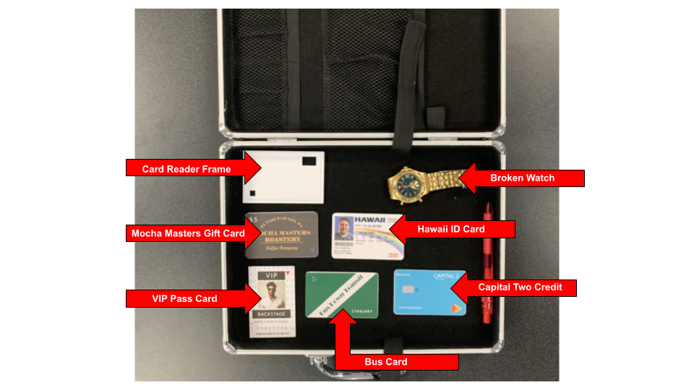

* Card Reader Frame
* Pen
* Broken Watch
* Attacker Cards
  + VIP Pass
  + Capital Two Credit Card
  + Mocha Masters Gift Card
  + Hawaii ID
  + Bus Card

**Ensure the silver box contains the following artifacts:**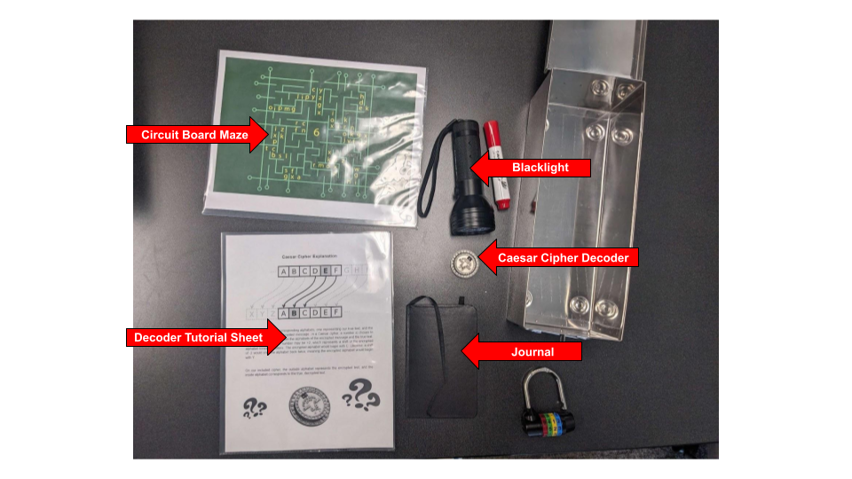

* Caesar cipher decoder
* Decoder tutorial sheet
* Marker
* Journal
* Blacklight
* Circuit board maze

Don’t crease the papers (decoder sheet and circuit board maze) just lay them on top of the other artifacts within the box.

Close the silver box and lock it by attaching the colored combination lock. The correct code is 2745. Shuffle the code before giving the players the silver box.

**Ensure the “Leaks” folder contains the following papers:**

* Introduction
* News Article
* *Maze of Memories*
* *Never Ending Game*
* *Tight Ending*

**Ensure the “Security Footage” Folder contains:**

* 10 Frames of Security
* Most importantly: the frame with the 11:35:00 time stamp.

Once you are sure all artifacts are in the correct places, give the players both folders and both boxes (silver box is still locked). Instruct them to visit:

<https://cybersecurityescaperoom.github.io/CyberEscapeBeginning/>

**CLEAN UP**

**DO NOT SHOW THIS TO THE PLAYERS**

**DO NOT REMOVE THIS FILE OR THE HINTS FILE FROM THE BINDER**

Upon completion of the puzzles and cyber security training, pack all artifacts into their respective boxes or folders stated in the SET UP section.

**If using the same computer or browser for multiple teams**, ensure previous passcodes have been deleted from the text entry on the following sites:

<https://cybersecurityescaperoom.github.io/CyberEscapeBeginning/Name%20Entry.html>

<https://cybersecurityescaperoom.github.io/Attacker-Desktop/>

Place both manilla folders in the left-hand side of the red “SET UP & SOLUTIONS” binder.

Place all extraneous files in the right-hand side of the binder.

**CONTINGENCY**

**If you need to reprint:**

Find all files in the Cyber Escape Room Google Drive:

<https://drive.google.com/drive/folders/1Pttx97CBqMVduYDaPpEgU2e3N1Imk_u2?usp=sharing>

Use invisible ink to write the following hints:

* At the top of “Maze of Memories”, write “star = R”

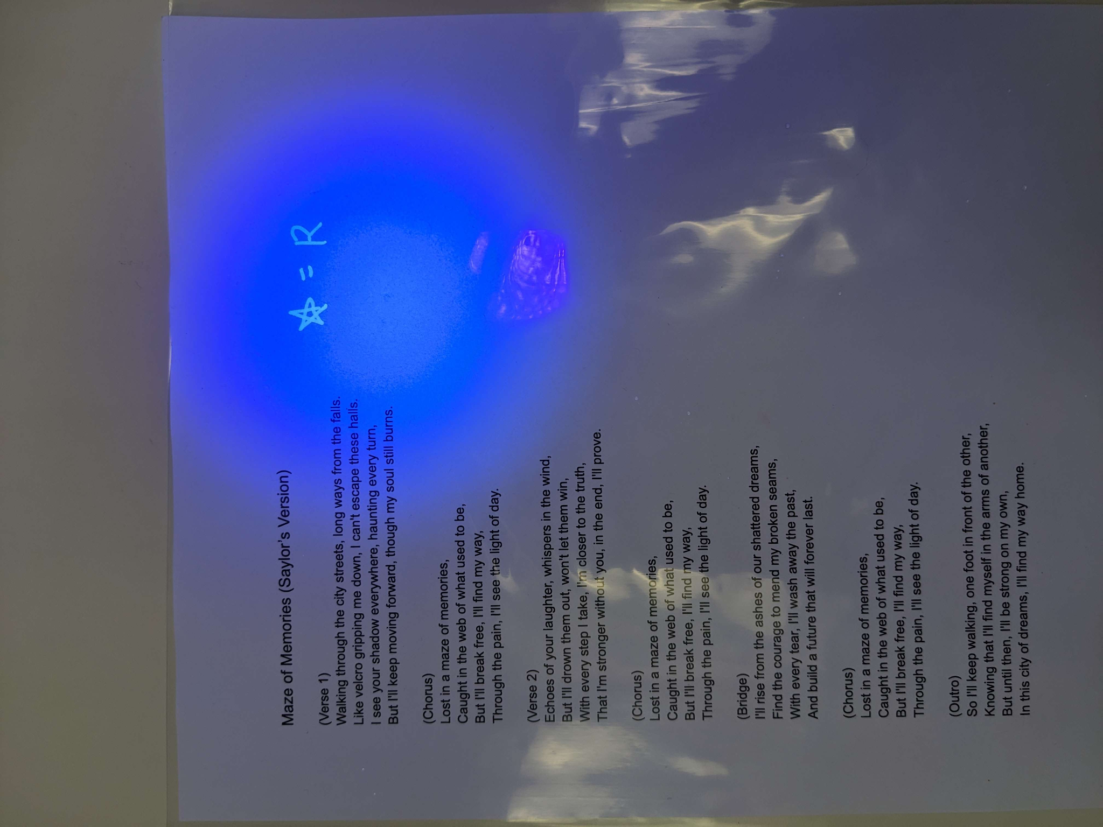

* At the top of “Never Ending (Football) Game”, write “circle = E”

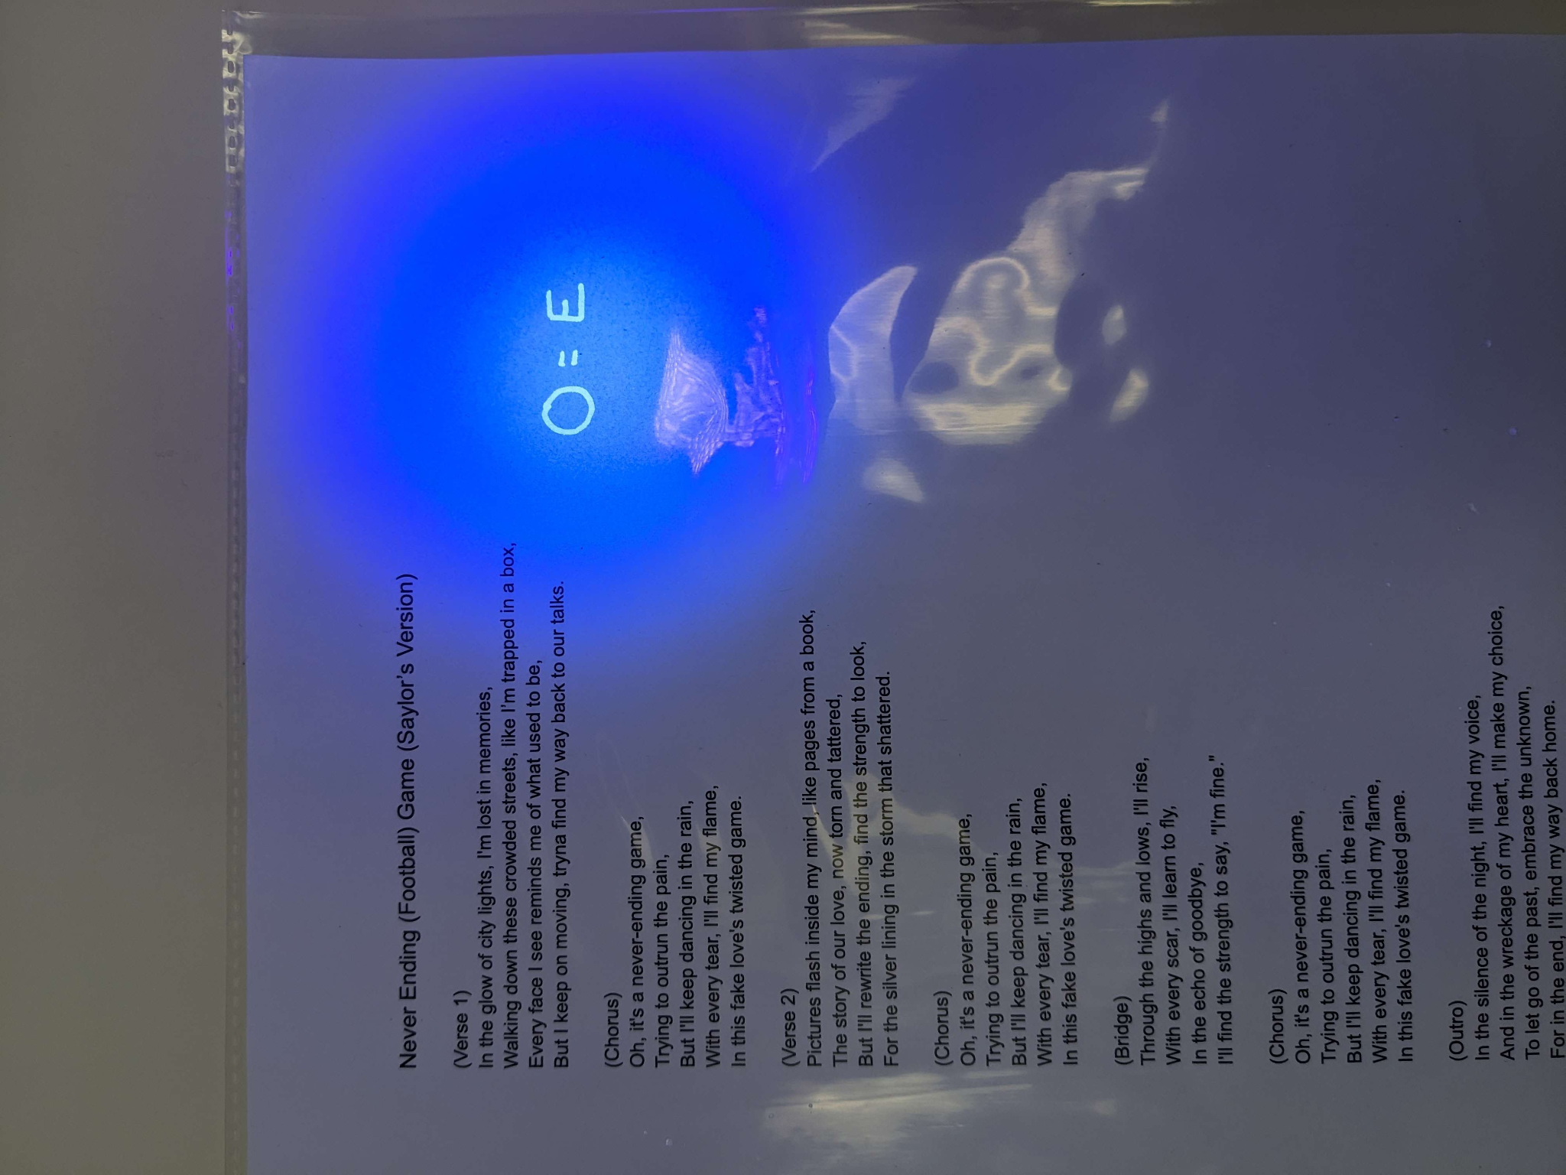

* At the top of “Tight Ending”, write “heart = D”

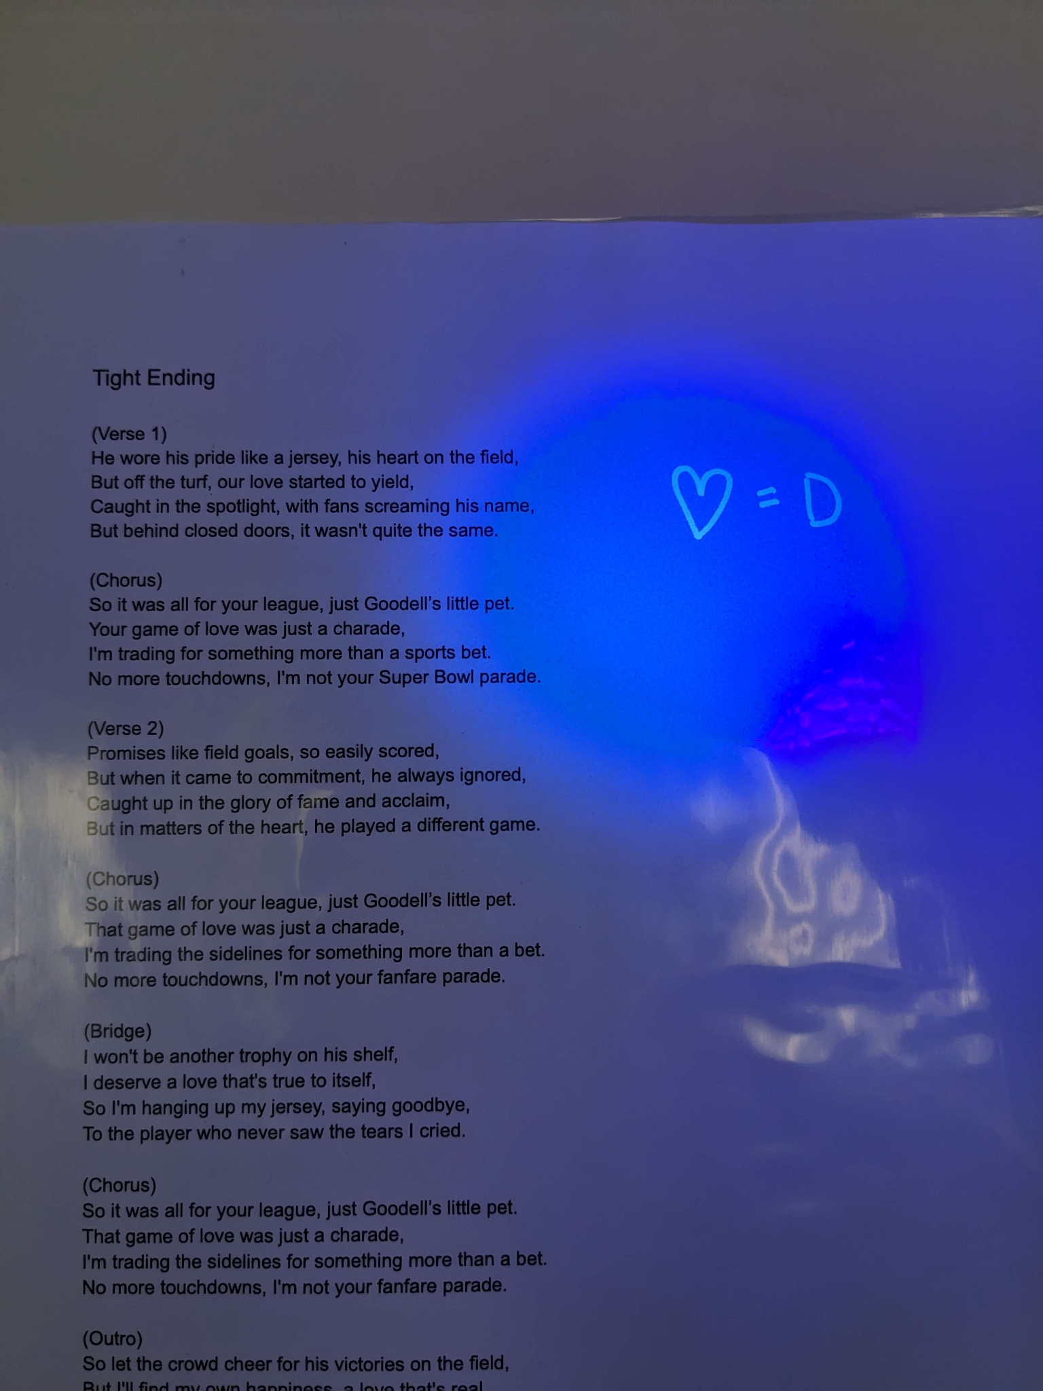

* At the top of the newspaper article, write “rectangle = 19”

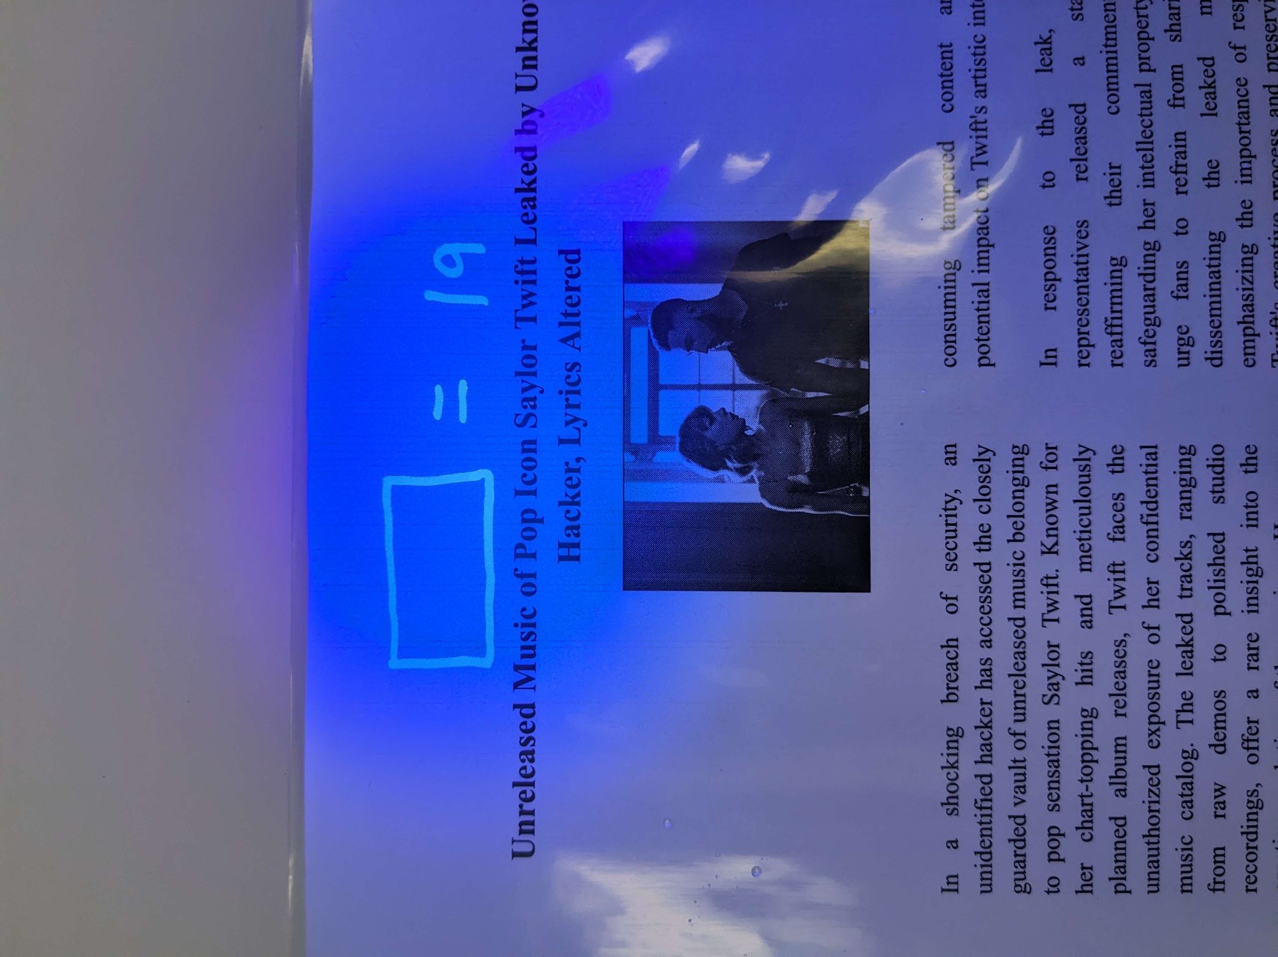

* At the bottom of the newspaper article, write “triangle = 89”

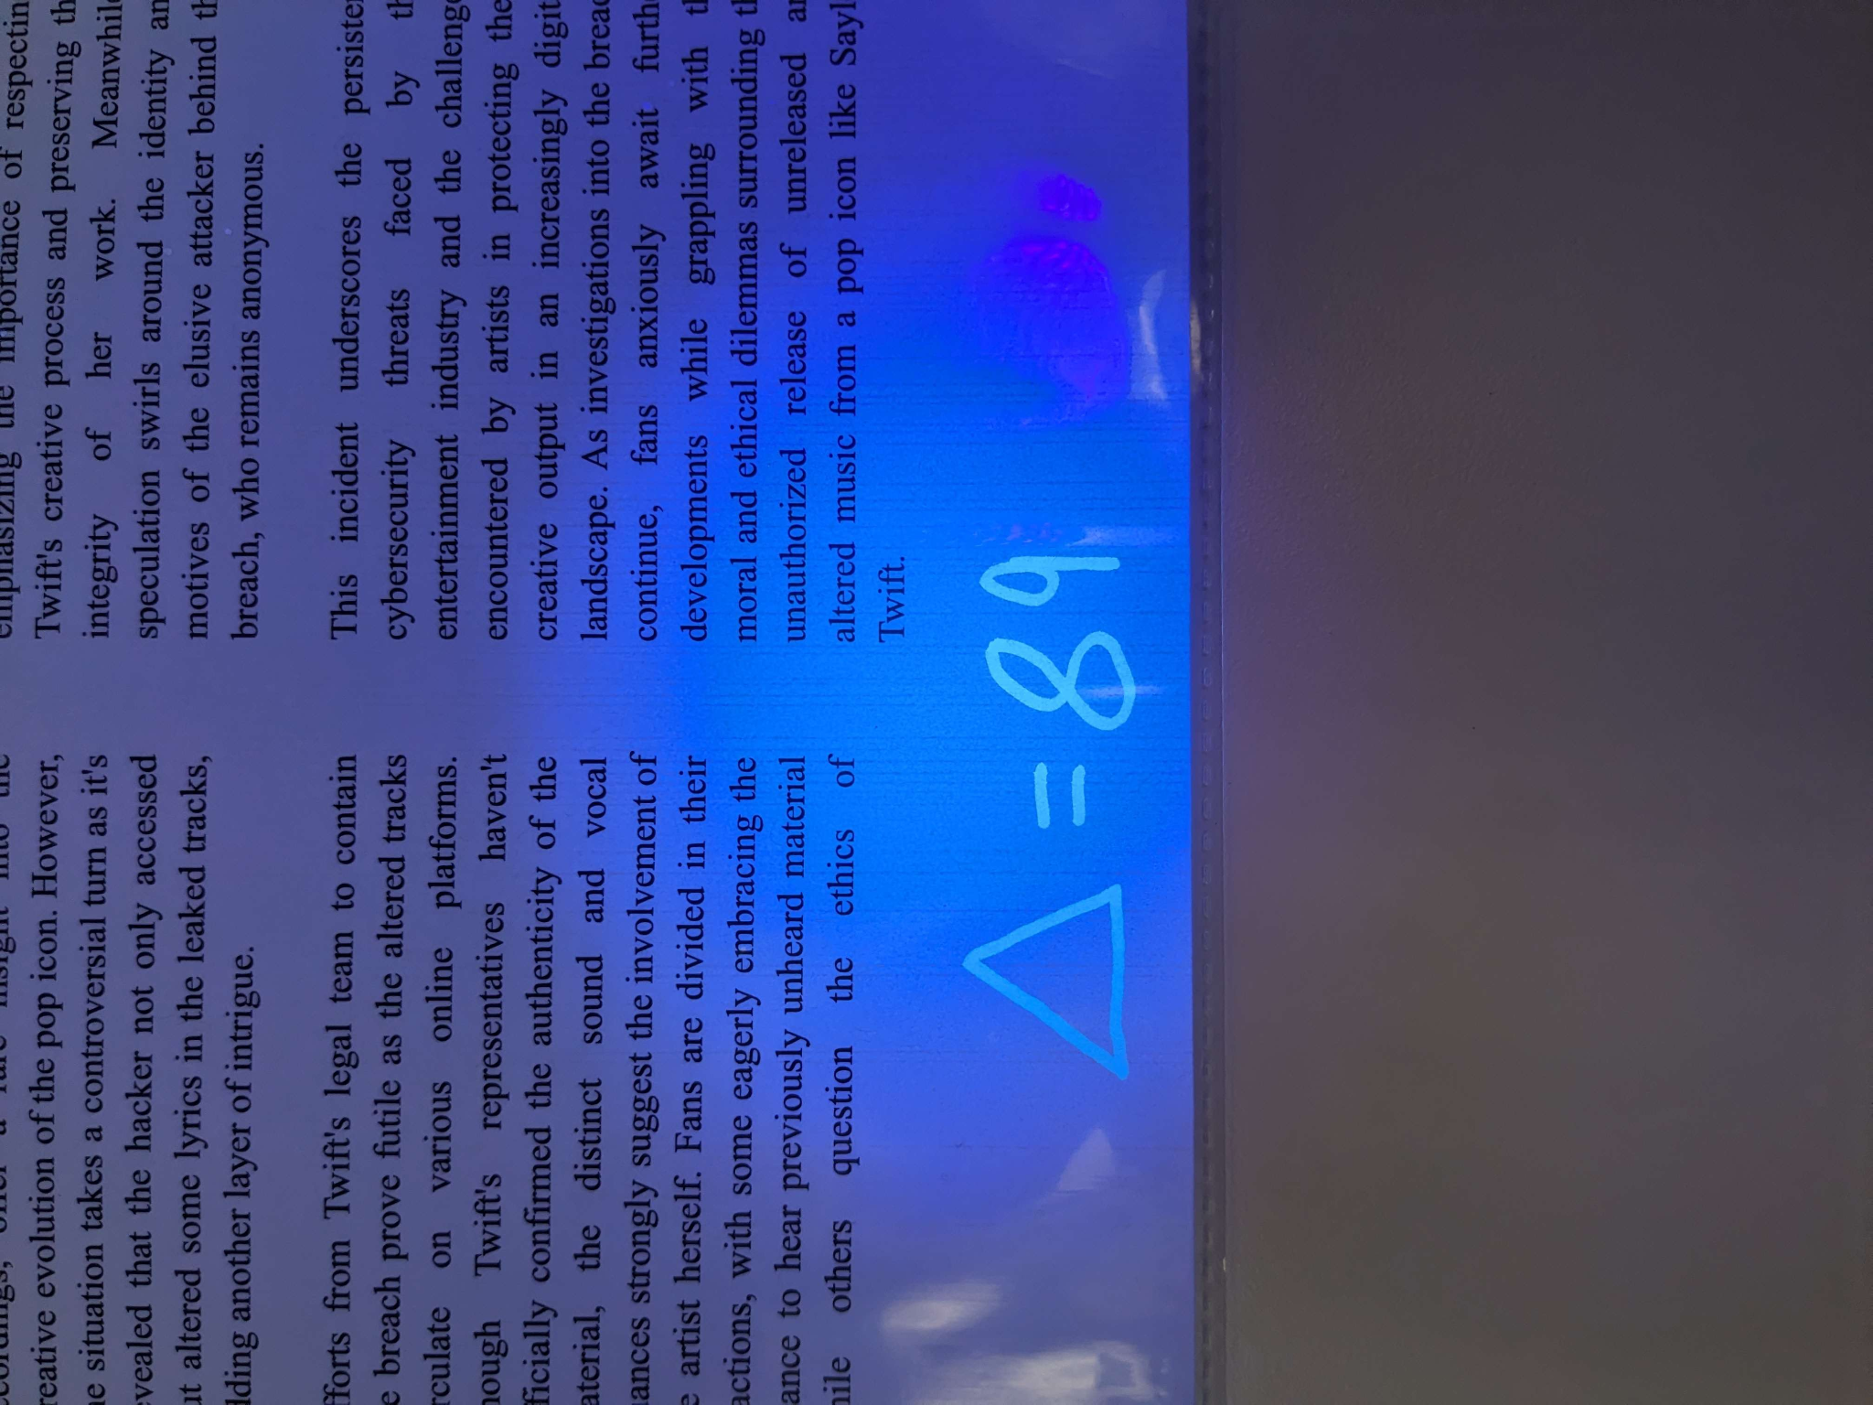

Journal:

* Number every page with a pen. On pages 66 and 67 write the following link in invisible ink: <https://cybersecurityescaperoom.github.io/HackerDesktop/>

Watch:

* You will need to buy a new watch and make sure the time is always stuck at 11:35.

**If you need to buy new artifacts:**

* Visit the Amazon links file: <https://docs.google.com/document/d/1udgI8NcfMka-cA0EJusf-e2QMR3U5OWiQQq8_19wNFk/edit?usp=sharing>

**SOLUTIONS AND EXPLANATIONS**

**DO NOT SHOW THIS TO THE PLAYERS**

**DO NOT REMOVE THIS FILE FROM THE BINDER**

1. Among the items in the briefcase, the player will find a few cards the attacker left behind. There is a red herring associated with it. They will need to place the frame over top of a few of the cards, revealing a colored shape with an associated number. For example, the color purple might be associated with the number 7. They will need these colors and corresponding numbers to open the lockbox. The password is 2745.
2. The player will also be given a manila folder filled with security images taken of our attacker. They will need to sync the time of the broken watch to one of the security images. This will provide them with the page number they need to visit in the included journal. On this page, they will find a URL they need to visit to continue.
3. Upon visiting the URL, they will have “hacked” into the attacker’s computer, however, they still need the password. From here, they need to solve the maze and string together the letters that their solution line crosses through. They need to take these seemingly random letters and decode them using the included Caesar cipher. The answer will be a combination of shapes.
4. Using the blacklight, the player will reveal shapes hidden throughout the previous artifacts. These shapes will have corresponding codes. The player must substitute these shapes for the codes and enter them as the password to the attacker’s computer. The password is RED1989.
5. Upon gaining entry to the attacker’s computer, the players must search for the attacker’s name. They will combine the first and last names, found in different documents, and enter them into the first website.
6. They will be congratulated for their work and read through a short module on cybersecurity.